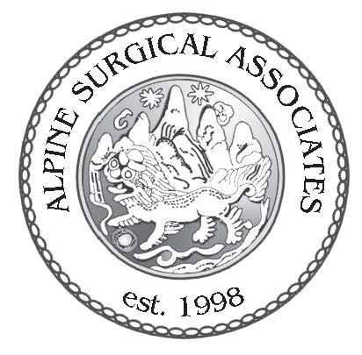
Mark J Hermacinski MD FACS
940 Central Park Drive Suite 200
Steamboat Springs Colorado 80487
Phone (970) 879 9299 Fax (866) 228 0896

Post Operative Home Care Instructions

- You may shower 48 hours after surgery, but do not pick or scrub at the incision sites.

- You may soak in a bath tub, sauna, hot tub or pool when your incision is healed. Generally after 1 week.

- You may remove the outside gauze bandage to shower 48 hours after surgery.

- Steri-strips on the wound will gradually loosen over the post operative period. Generally 1-2 weeks. They may be removed after one week.

- Call the office if you have questions, uncontrolled pain, fever, discharge from the incision, nausea, or vomiting.

- Signs of infection are redness, swelling, drainage, warmth, and increased pain, fever greater than 101 or chills.

- You may experience some incision soreness or some incision discomfort. This is normal and should continue to resolve with healing.

- Make sure you walk and change positions frequently after surgery to help keep your blood circulating and prevent blood clots. Rest in a position of comfort.

- You may return to driving as soon as you feel comfortable following the day of your surgery and all narcotic pain medications have been stopped.

- You may return to desk work 5 - 7 days after surgery if you are feeling up to returning. More physically demanding jobs may require a longer time off work. We can work together to determine the best course for individual needs.

